

TECHNOLOGY

Name: AFWERKI GHIRMAY

Student ID: P1095278

Lecturer: Gayathri Karthri

# Neural Network Rapid Prototyping

Table of Contents

Neural Network Rapid Prototyping 1

Introduction 4

Task 1: Demonstrate your knowledge in Artificial Neural Network 4

What is Artificial intelligence? 4

1. Different paradigm of Neural Network 4

What is ML (Machin learning) 4

What can ML do? 4

A training set 4

A validation set 5

A test set 5

Deep learning 5

How did deep learning take Machin learning to the next level? 5

Artificial neural networks (ANNs) 5

Biological neurons 5

How does an ANN learn? 6

ANNs and the backpropagation algorithm 6

Forward and backward passes 6

Neural network architectures 7

Deep neural networks (DNNs) 7

Multilayer Perceptron 8

Deep belief networks 8

Autoencoders 9

Convolutional neural networks 10

Recurrent neural networks 11

Emergent architectures 11

2 Neural Network in Human-Centric Artificial Intelligence for Smart cities 12

**Human-centred** 12

3 Deep learning software models/tools 13

Scikit-Learn 13

TensorFlow 13

Azure machine learning studio 14

Jupyter Notebook 14

Advantages of jupter notebook 15

Exploratory Data Analysis: 15

Simple Caching in Built-In Cell: 15

Language Independent: 15

Data Visualisation: 15

Live Interactions with Code: 15

Documenting code samples: 15

Pytorch 16

4 Compare SDLC model with Neural Network model. 16

What is SDLC(system life cycle)? 16

Task 2: Implement train and test a neural network model 17

short scenario 17

1. Downloading the dataset 17

2. Prepare the dataset for feeding into the neural network model. 18

A. Data preparation 18

Normalizing data 18

Cleaning to missing data 20

B. Splitting the data 20

Task 3: The accuracy of the outcome using neural network model 21

5. Choice of your Neural Network Algorithm 21

What is Two-Class LogisticRegression model and why am I using it? 21

6. Train the dataset and discuss about the outcome 22

The next step is to score 23

7. Validation 24

To clarify a bit more. 26

8. Tune the model 26

Total survivability of the passengers 26

Survivability based on gender 27

Survivability based of classes 27

Finally the web API 28

Conclusion 28

Bibliography 29

# Introduction

Building intelligent systems that can perform human behaviour has caught the attention of the world in recent past. So, it isn't surprising that technology, for example, neural networks has created extraordinary enthusiasm for pattern recognition. This chapter starts with a perspective on what neural systems are and why they are so appealing.

A typical biological neuron is explained to comprehend the idea used in artificial neuron model. With this essential idea, a simple neuron model has been described including the principal neural network, for example, input, hidden and output layers and association between the layers, types of neural network, transfer function and learning algorithms.

# Task 1: Demonstrate your knowledge in Artificial Neural Network

### What is Artificial intelligence?

Artificial intelligence is the field of computer science that seeks to build autonomous machines. This machines can carry out complex tasks without human intervention. This goal requires that machines be able to perceive and reason. Such capabilities fall within the category of common sense activities that, although natural for human mind, have historically proven difficult for machines.

The result is that work in the filed continues to be challenging. After a lot of progress that has been made, many problems in the filed continue to cost a lot. Therefore, researchers come up with two different ideas. One was genetic algorism and the other was ANN (artificial neural network). As this topic is about ANN I will leave genetic algorisms behind and progress with ANN.

## Different paradigm of Neural Network

Before I move to ANN (artificial neural networks) I would like in emphasise a bit more about ML (Machin learning)

## What is ML (Machin learning)

ML is about statistical and mathematical algorism to do some tasks. For example, classification, regression analysis, concept learning, predictive modelling, clustering and meaning of patterns.

### What can ML do?

* Learn from data and histories.
* Improve experience.
* Predict outcome of some questions.

Machin learning can be divided by three sets. This are training set, validation set and test set.

### A training set

Is an information that come from historical or live data to fit the parameter of Machin learning algorism

### A validation set

Is a collection of example used to tune the parameter of an ML model. The importance is to train the model very well and generalize to avoid over fitting. Sometimes it’s called development set or DEV SET.

### A test set

Is important to check the performance of the trained model on unseen data. Once we assess the final model we can deploy it to a production-ready environment. This set is sometimes called model inferencing.

In ML the best practice is splitting the input data 60% for training, 10% for validation and 20% for testing. But this might be different based on the scenario.

## Deep learning

The basic machine learning methods that has been used in normal size data are not supportive any more. Therefore, Machin learning must be replaced by more capable Machin learning methods.

Although classical ML techniques allow researchers to identify groups or clusters of related variables, the accuracy and effectiveness of this methods diminish with large and high-dimensional datasets.

Her comes deep learning which is one of the most important development in artificial intelligence in the last few years. Deep learning is a branch of ML based on a set of algorisms that attempt to model high-level abstraction data.

## How did deep learning take Machin learning to the next level?

Deep learning algorisms are a set of ANNs that can make the large-scale data easily understandable.

# Artificial neural networks (ANNs)

ANNs is a large scale parallel network system consisting of basic block called neurons. These neurons are inter-connected in single or multi layers. This are biologically inspired.

They are made out of elements that act in a way that is undifferentiated from the most basic elements of the biological neurons. These elements are then composed in a manner that may (or may not) be identified with the life systems of the brain.

Regardless of this shallow similarity, ANNs show various brain attributes. An old style comparison of the data handling abilities of the human and the PC is featured by an endeavour to automate human data processing. The PC can duplicate huge numbers at rapid yet it can't perceive unconstrained, speaker-autonomous speech.

Human capacities supplement those of PC by effectively recognizing speech, in any event, when it is slurred and the environment is noisy. A traditional PC utilizes calculation based program that works sequentially and is constrained by a central processing unit, and stores data at addressed locations in memory.

However, brain works with profoundly conveyed changes that work in parallel, have distributed control through a great many interconnected neurons, and seem to store data as distributed connection among the neurons.

# Biological neurons

The idea of ANNs is coming from a human brain. The receptors receive the stimuli either internally or from the external world; then they pass the information into the biological neurons for further processing.

There are a number of dendrites, in addition to another long extension called the axon. Towards its extremity, there are minuscule structures called synaptic terminals, used to connect one neuron to the dendrites of other neurons. Biological neurons receive short electrical impulses called signals from other neurons, and in response, they trigger their own signals:

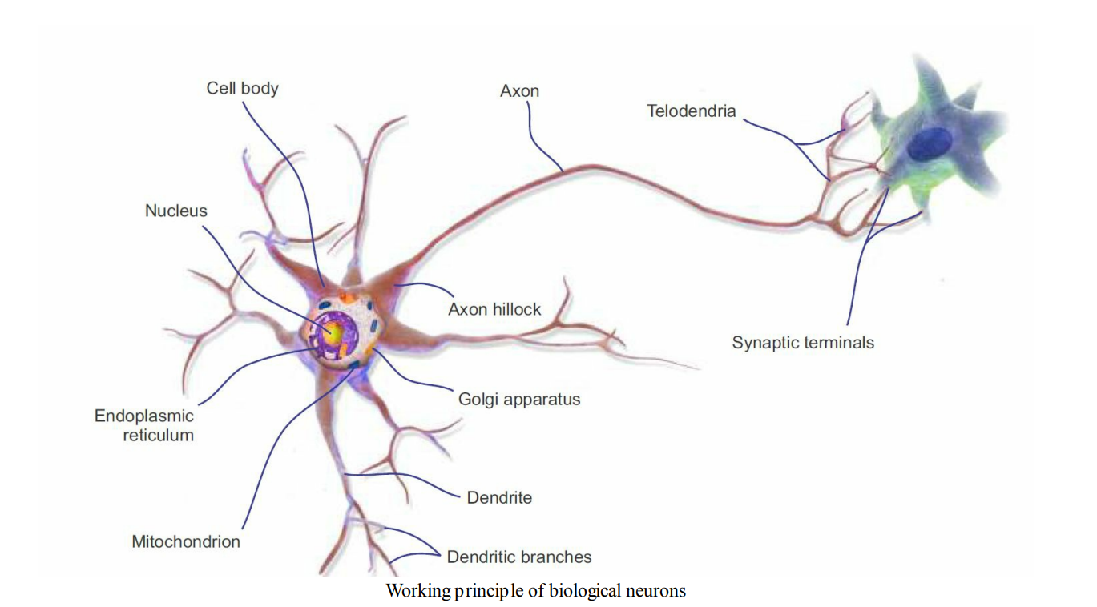

We can thus summarize that the neuron comprises a cell body (also known as the soma), one or more dendrites for receiving signals from other neurons, and an axon for carrying out the signals generated by the neurons. A neuron is in an active state when it is sending signals to other neurons.

However, when it is receiving signals from other neurons, it is in an inactive state. In an idle state, a neuron accumulates all the signals received before reaching a certain activation threshold. This whole thing motivated researchers to introduce an ANN (Brookshear, 2018).

# How does an ANN learn?

From the idea of biological neurons ANs consists of the following

* One or more incoming connections that aggregate signals from neurons.
* One or more output connections for carrying the signal to the other
* Neurons.
* An activation function, which determines the numerical value of the output signal.

## ANNs and the backpropagation algorithm

The importance of this algorism is to overcome the errors between the current and expected output. As the network is feedforward, the activation flow always flows from the input units to the predicted outcomes. The gradient of the cost function is backpropagated and the network weights get updated; the overall method can be applied to any number of hidden layers recursively. In such a method, the incorporation between two phases is important. In short, the basic steps of the training procedure are as follows:

1. Initialize the network with some random (or more advanced XAVIER)

Weights

2. For all training cases, follow the steps of forward and backward passes as outlined next

## Forward and backward passes

In order to induce the prediction or score within the forward operation some operations has got to be performed. during this operation graph is made and linking all the dependant operation within the top-to-bottom fashion. Once the operation is don the network’s error are going to be computed.

Which shows the difference between the ultimate goal and also the current output.

however, the backward pass is involved mainly with mathematical operations, like creating derivatives for all differential operations (that is auto-differentiation methods), top to bottom (for example, measuring the loss function to update the network weights), for all the operations within the graph, and then using them in chain rule. In this pass, for all layers starting with the output layer back to the input layer, it shows the network layer's output with the right input (error function). Then it adapts the weights within the current layer to reduce the error function.

This is often backpropagation's optimization step. There are two forms of auto differentiation methods:

1. Reverse mode: Derivation of one output with relevancy all inputs

2. Forward mode: Derivation of all outputs with relevance one input the backpropagation algorithm processes the knowledge in such the simplest way that the network decreases the worldwide error during the educational iterations; however, this doesn't guarantee that the world minimum is reached. The presence of hidden units and therefore the nonlinearity of the output function mean that behaviour of the error is incredibly complex and has many local minimas.

This backpropagation step is usually performed thousands or numerous times, using many training batches, until the model parameters converge to values that minimize the price function. The training process ends when the error on the validation set begins to extend, because this might mark the beginning of a phase overfitting.

## Neural network architectures

There are so many architectures in neural network. This neural network architecture can be divided by 4 categories. This are:

1. Deep neural networks(DNNs)
2. Recurrent neural networks(RNNs)
3. Convolutional networks(CNNs)
4. Emergent Architectures (EAs)

## Deep neural networks (DNNs)

DNNs are neural systems having mind boggling and more profound engineering with an enormous number of neurons in each layer, and there are numerous connections. The calculation in each layer changes the representations in the subsequent layers into somewhat progressive abstract representations. however, I am going to use the term DNN to refer explicitly to the multilayer Perceptron (MLP), the Stacked Auto-Encoder (SAE), and Deep Belief Networks (DBNs).

SAEs and DBNs use AEs and Restricted Boltzmann Machines (RBMs) as building blocks of the structures. The principle contrast among these and MLPs is that training is executed in two stages: unsupervised pre-training and supervised fine-tuning.

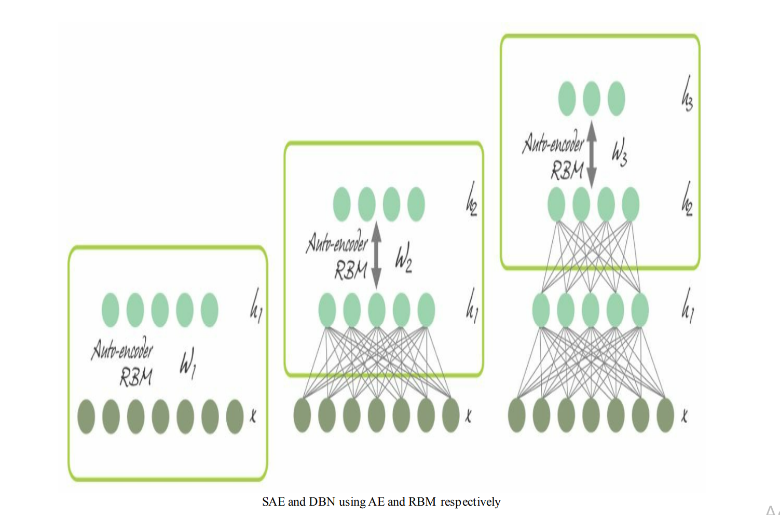

### Multilayer Perceptron

As examined before, a single perceptron is even incapable for approximating a XOR work. To defeat this constraint, various perceptrons are stacked together as MLPs, where layers are associated as a directed graph. this way, the sign spreads one way, from input layer to hidden layers to output layer, as appeared in the following diagram:

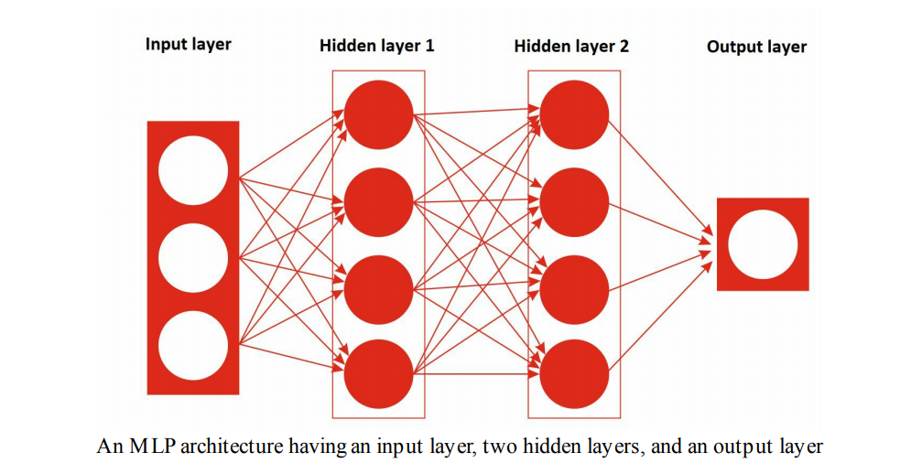

On a very basic level, a MLP is one the most basic FFNNs having at least three layers: an input layer, a hidden layer, and an output layer. An MLP was first trained with a backpropagation algorithm during the 1980s.

### Deep belief networks

To defeat the overfitting issue in MLPs, the DBN was proposed by Hinton et al. It utilizes a greedy, layer-by-layer, pre-preparing algorithm to initialize the system loads through probabilistic generative models. DBNs are made out of a visible layer and multiple layers—hidden units.

The main two layers have undirected, symmetric associations in the middle and form an associative memory, though lower layers get top-down, directed connections from the former layer. The building blocks of a DBN are RBMs, as it shows on the following figure, where a few RBMs are stacked consistently to shape DBNs:

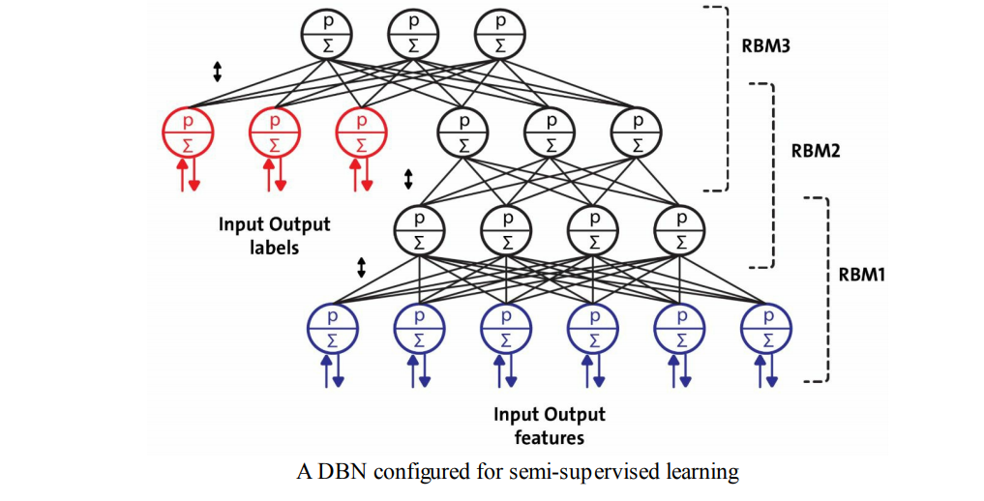

A single RBM comprises of two layers. The first layer is made up of visible neurons, and the second layer made up of hidden neurons. as the figure below shows the structure of a simple RBM, where the neurons are organized by a symmetrical bipartite diagram: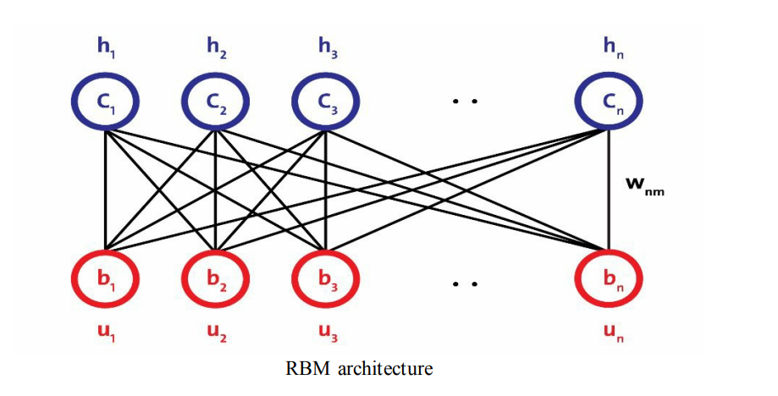

In DBNs, a RBM is trained first with input information, called unsupervised pretraining, and the hidden layer represents the features learned using a greedy learning approach called supervised fine-tuning. In spite of various victories, DBNs are being replaced by AEs.

### Autoencoders

An AE is a system with at least three layers, where the input layer and the output layer have a similar number of neurons, and those intermediate (hidden layers) have a lower number of neurons. The network is trained to duplicate in the output, for each bit of input information, a similar pattern of action as in the input.

Helpful application of AEs are information denoising and dimensionality decrease for data visualisation. The following diagram shows how an AE regularly functions. It recreates the received input in two stages: an encoding stage, which relates to a dimensional reduction for the first input, and a decoding stage, which is capable for reconstructing the first input from the encoded (compressed) representation:

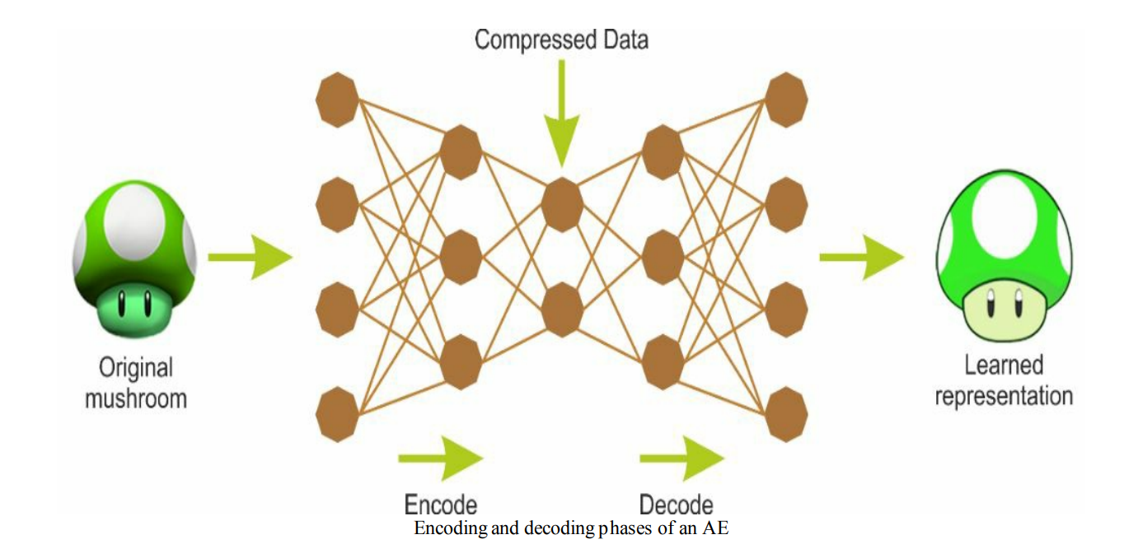

## Convolutional neural networks

CNNs have accomplished a lot and wide adoption in computer vision (for instance, image recognition). In CNN networks, the connection scheme that defines the convolutional layer (conv) is significantly different compared to an MLP or DBN. Significantly, a DNN has no prior knowledge on how the pixels are composed; it doesn't realise that close by pixels are close.

A CNN's engineering embeds this prior knowledge. Lower layers commonly identify features in little space of the picture, while higher layers join lower-level features into bigger features. This functions well with most natural images, giving CNNs a decisive head begins once again DNNs:

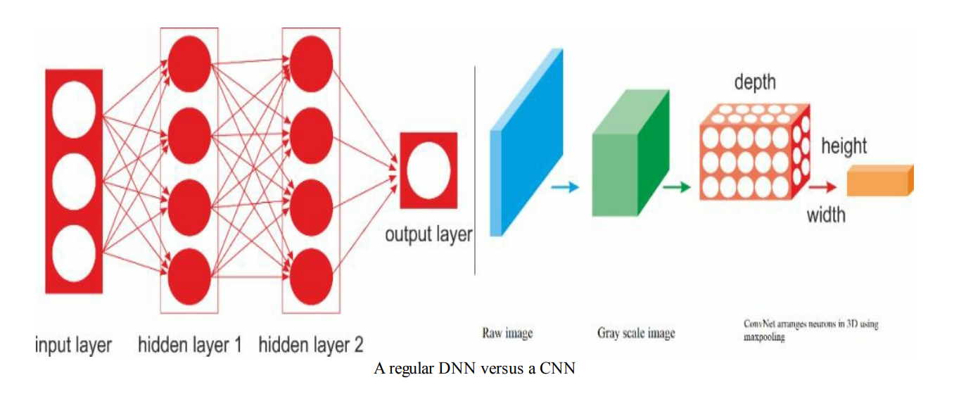

Take a glance the previous diagram; on the left could be a regular three-layer neural system, and on the proper, a CNN arranges its neurons in three measurements (width, height, and depth). in a very CNN architecture, a pair convolutional layers are connected in a very cascade style, where each layer is followed by a ReLU layer, then pooling layer, then a pair more convolutional layers (+ReLU), at that time another pooling layer, etc.

The output from each conv layer could be a collection of objects called feature maps that are created by one kernel filter. then the feature maps will be accustomed define a brand new input to the subsequent layer. Every neuron during a CNN network produces an output followed by an activation threshold, which is proportional to the input and not bound. this type of layer is understood as a convolutional layer. the subsequent diagram may be a schematic of the architecture of a CNN used for facial recognition:

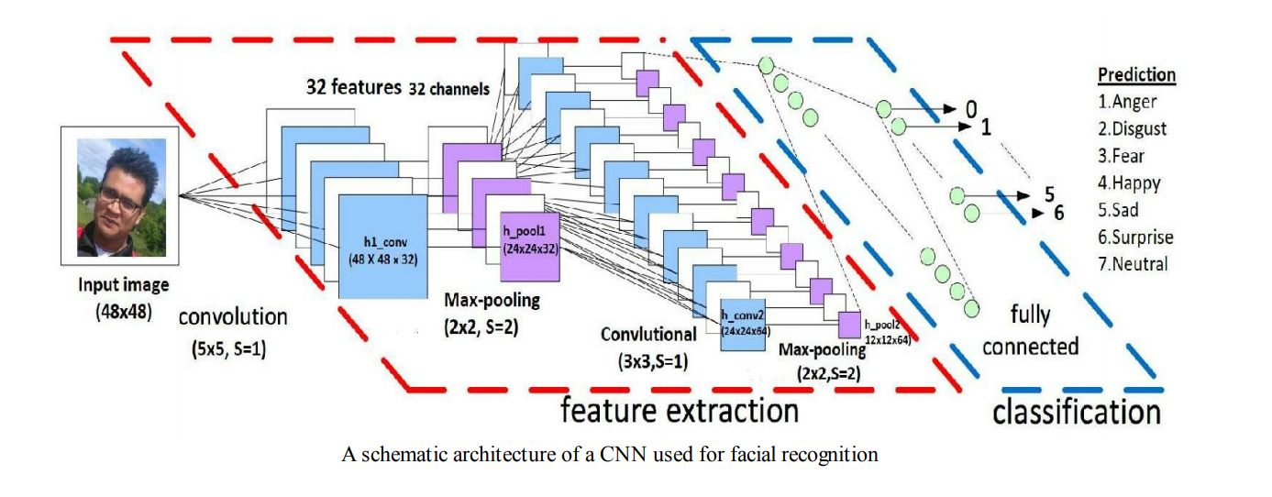

## Recurrent neural networks

A recurrent neural system (RNN) is a class of artificial neural system (ANN) where connections between units form a directed cycle. RNN design was initially brought by Hochreiter and Schmidhuber in 1997. RNN architectures have standard MLPs in addition to loops (as it shows on the following diagram), so they can exploit the powerful nonlinear mapping abilities of the MLP; and they have some type of memory: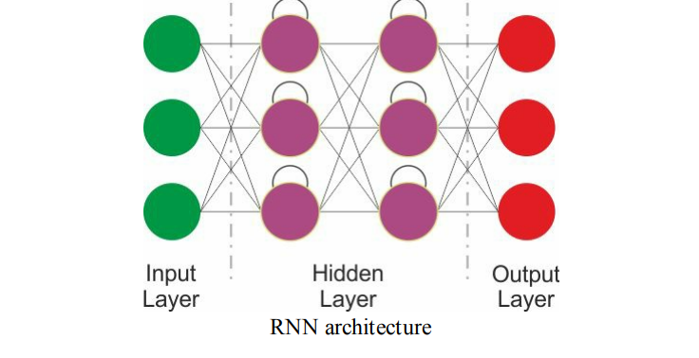

The previous picture shows an essential RNN having an input layer, 2 recurrent layers and an output layer. however, this fundamental RNN experiences slope evaporating and exploding issue and can't model the long-term dependencies. Accordingly, further developed models are designed to use consecutive data of info information with cyclic associations among building blocks, for example, perceptrons.

These architectures incorporate Long-Short-Term Memory (LSTM), Gated Recurrent Units (GRUs), Bidirectional-LSTM and different variations. Thus, LSTM and GR can overcome the drawbacks of standard RNNs: gradient evaporating/exploding issue and the long-short dependency.

## Emergent architectures

Numerous other developing DL architectures have been recommended, for example, Deep SpatioTemporal Neural Networks (DST-NNs), Multi-Dimensional Recurrent Neural Networks (MD-RNNs), and Convolutional AutoEncoders (CAEs). Nevertheless, there are a couple of all the more developing systems, for example, CapsNets (which is an improved form of a CNN, designed to remove the downsides of ordinary CNNs), RNN for image recognition, and Generative Adversarial Networks (GANs) for basic image generation. Aside from these, factorization machines for personalization and deep reinforcement learning are likewise being used generally.

## Neural Network in Human-Centric Artificial Intelligence for Smart cities

People are progressively coming into contact with artificial intelligence and ML systems. Human-centred artificial is a viewpoint on AI and ML that algorithms must be structured with mindfulness that they are a piece of a bigger framework consisting of people. Human-centred AI can be divided by two aspects.

1. AI frameworks that understands the people from a sociocultural point of view, and

2. AI frameworks that assist people with understand them. We further argue that issues of social duty, for example, fairness, responsibility, interpretability, and transparency.

**Human-centred**

Artificial intelligence is a point of view on AI and ML that intelligent system must be designed with mindfulness that they are a piece of a larger system comprising of human partners, for example, clients, administrators, customers, and others right up front area.

Some AI analysts and experts have begun to use the term human-centred AI to refer to intelligent system that are structured with social obligation at the top of the priority list, for example, tending to issues of fairness, responsibility, interpretability, and transparency. Those are significant issues.

Human-centred artificial intelligence can incorporate more than those issues and in this desiderata we take at the border scope to determine the importance of human-centred AI, including factors that underlie our requirement for decency, interpretability, and transparency.

Human-centred AI is the recognition that the way intelligent systems solve problems—especially when using machine learning—is fundamentally alien to humans without training in computer science or AI. We are used to connecting with others, and we have grown amazing capacities to anticipate what others will do any why. This is now and then referred to as hypothesis of brain—we can speculate about the activities, convictions, objectives, goals, and needs of others.

However, our hypothesis of mind separates while communicating with intelligent system, which don't take care of issues the way we do and can and think of unusual or surprising solutions in any event, when functioning as planned. This is additionally exacerbated if the intelligent system is a "black box." Black box AI and ML refers to the circumstances where client can't comprehend what algorithms utilizes, or that the system is so complicated to oppose simple assessment. Whether or not an intelligent system is a black box or not, we are seeing more communication between intelligent systems what's more, individuals who are not specialists in AI or computer science.

How might we design intelligent systems that are capable for helping individuals comprehend their choices? Must we design intelligent systems to take care of issues

progressively like people, or would we be able to expand existing algorithms? What do individuals need to think about an intelligent system to have the option to trust in its choices or be open to working with an AI? Can the intelligent system itself pass on this data to its clients in an important and justifiable way?

Human-centred AI is additionally an acknowledgment of the way that people can be

similarly intractable to intelligent systems. At the point when we consider intelligent system understanding people, we generally consider natural language and speech processing whether an intelligent system can react properly to expressions.

natural language processing, speech recognition, and activity recognition are important challenges in building helpful, interactive system. To be genuinely viable, AI and ML systems need a theory of mind about people.

Similarly as we use our common sense thinking to interpret and anticipate the activities of others, intelligent system can profit by having realistic understanding of what individuals do and why they do it specifically ways; we are unconsciously impacted by our sociocultural convictions. intelligent systems, however, don't "grow up" immersed in a general public and culture in the manner in which people do.

These sociocultural convictions and standards give a setting encompassing everything that individuals do. An intelligent system that can demonstrate sociocultural beliefs and standards might have the option to disambiguate human conduct and make increasingly educated guesses on the best way to anticipate also, react to human needs.

At the very least, intelligent system that better comprehend the sociocultural underpinnings of human conduct might be less likely to commit errors about subjects that individuals underestimate, making them more secure to utilize and more secure for them to be in closeness to individuals. It may also be conceivable some time or another for intelligent system to assess their own practices for consistency with moral standards about decency.

AI and ML that are human-centred

(1) have an understanding of human sociocultural standards as a component of a theory of mind about individuals, and (2) are capable for creating clarifications that non-master end-users can understand. These are hidden capacities from which quite a bit of our requirement for AI that adds to social great stems.

## Deep learning software models/tools

Machines learning comes from wide collection of machine learning tools, platforms and software. Here are some of the Machine learning models and.

## **Scikit-Learn**

Scikit-learn is a machine learning model that is available for everyone to use. It is unified platforms that is used for multiple purposes. Scikit-learn assists in regression, clustering, classification, dimensionality reduction, and pre-processing. Sckit-learn in made on top of the three core python libraries. Which are Numpy, Matplotlib, and SciPy. Along with this, it will also help you with testing as well as training your models.

## **TensorFlow**

Tensorflow is one of the top profound learning frameworks. It has been implemented in a few organizations, for example, IBM, Airbus, Twitter and some more, essentially because of the adaptability of its framework's design. The most renowned use case of TensorFlow framework is the Google Translate, joined with proficiencies in the summarization or classification of text, natural language processing, handwriting, picture and speech recognition, as well as tagging and forecasting. It is accessible on the desktop and cell phones, and it supports languages like C++, Java, Python, R, Julia and JavaScript for the production of profound learning models with wrapper libraries. TensorFlow has two extensively utilized instruments which are:

TensorFlow Serving: This instrument quickly conveys new calculations or analyses, while keeping up the first server design and API's. Moreover, it offers the chance to coordinate with different TensorFlow models, an element which is not quite the same as other conventional practices and can likewise be stretched out toto cater for other data and model types.

TensorBoard: This is an instrument for information to effectively visualize network modelling and its performance. When making the first steps with deep learning, it is reasonable to choose TensorFlow since it is Python-based and is additionally bolstered by Google. It accompanies heaps of documentation and steps for direction.

## **Azure machine learning studio**

Azure Machine Learning Studio or in short ML Studio is the a development environment for Azure ML. It's absolutely browser based and thus is open to use everywhere, for example, IE 10 or its later version. It additionally gives a community oriented condition where we can share our work to other people.

Machine learning Studio gives a visual workspace to build, test, and repeat on a predictive model effectively and intelligently. we can make a workspace and make experiment inside it. we can also consider making a test inside ML Studio as an undertaking where we can drag and drop datasets and analysis modules onto an interactive canvas, connecting them together to form a predictive model.

we can repeat our model's design, edit the experiment, save a copy if its needed, and run it again. once the training is done and everything is ready we uploads it on. the web service in order to be access by other person or other applications.

if we are not able to get what we want on the drag and drop ML studio also allows as to write a code using either python, R, or C#. moreover azure machine learning also provides a mode that allows to use SQL quires.

can't be met outwardly by relocating modules, ML Studio permits you to expand your examination by composing code in either R or Python scripting. It likewise gives you a module that permits you to play with information utilizing SQL inquiries."

Excerpt From: “Microsoft Azure Machine Learning”. Apple Books. 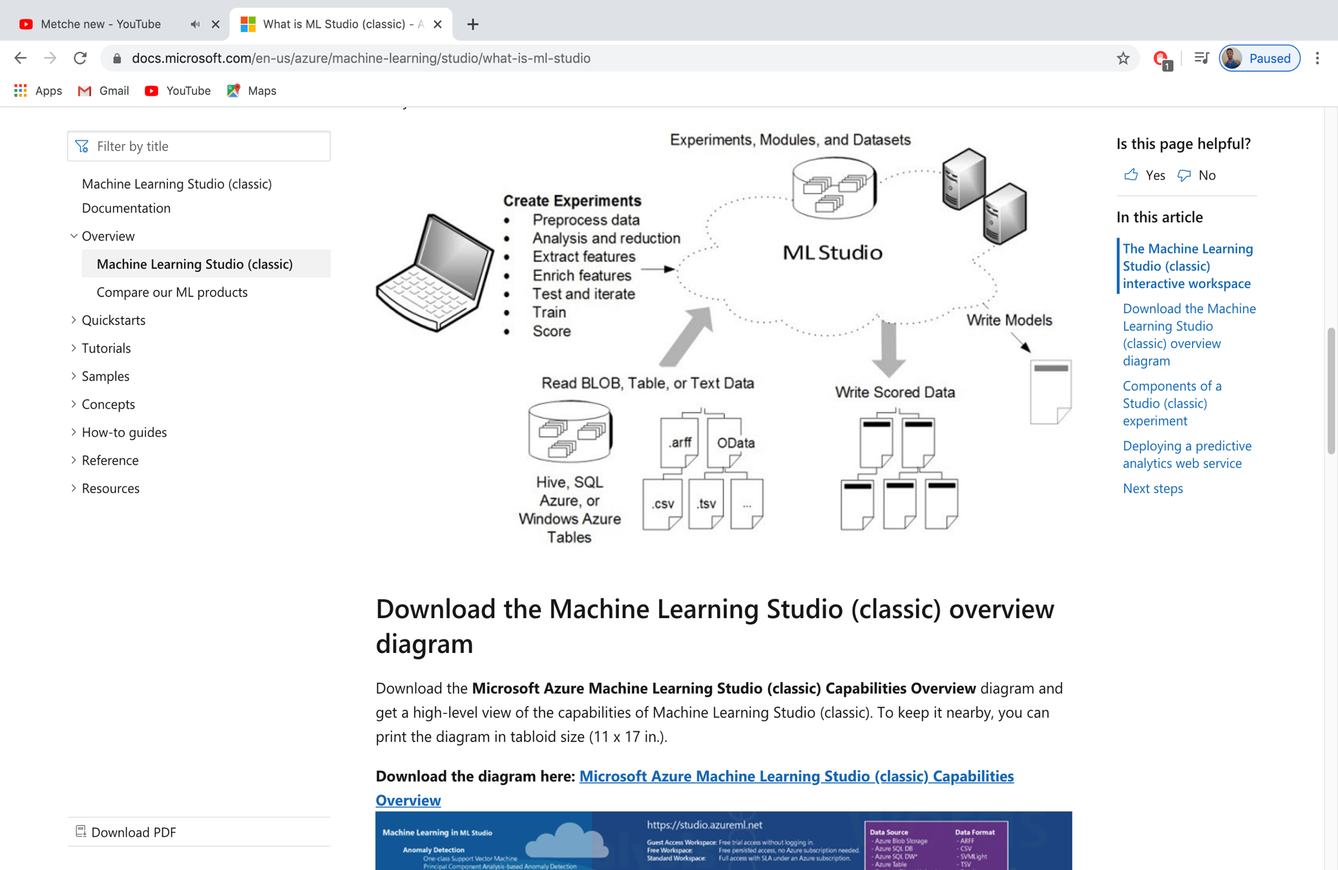

## **Jupyter Notebook**

Jupyter stands for three different languages which are Julia, python and R. notebook is customer oriented interactive web application that enable customers to create and share codes equations, visualisations, and text. Notebook is well known for multi-lingual interactive computing environment that enable user to use for more than 40 machine languages. Users can bring the data, code and prose together in the Jupyter notebook to create an interactive computational story.

The installation can be done in pip install from python or if anaconda is installed then jupyter notebook can be installed automatically.

The main importance of jupyter notebook are:

* Data cleaning
* Statistical modelling
* Training ML models
* Data visualisation

### Advantages of jupter notebook

Despite the fact that Jupyter has been created for data science applications, which are written in languages like Python, R and Julia, the platform is now utilized in a wide range of ways for projects. Aside from that, by evacuating the barriers for data researchers, Jupyter made documentation, data visualisation, and catching much easier, particularly for hardcore non-technical people. data science professionals stated, "Jupyter Notebook ought to be an essential piece of any Python data researcher's tool box. It's incredible for sharing notebooks with visualisations."

Here are some more benefits of Jupyter notebook.

Exploratory Data Analysis: Jupyter permits clients to see the results of the code in-line without the dependency of different pieces of the code. In the notebook, each cell of the code can be potentially checked whenever to draw an output. because of this, unlike to other standard IDEs like PyCharm, VSCode, Jupyter helps in-line printing of the output, which turns out to be very valuable for exploratory data analysis (EDA) process.

Simple Caching in Built-In Cell: Maintaining the condition of execution of every cell is difficult, however with Jupyter, this work is done automatically. Jupyter stores the result of each cell that is running — regardless of whether it is a code that is training a ML model or a code that is downloading gigabytes of data from a remote server.

Language Independent: Because of its representation in JSON format, Jupyter Notebook is platform-independent just as language-independent. Another explanation is that Jupyter can be handled by many languages, and can be changed over to any file formats, for example, Markdown, HTML, PDF, and others.

Data Visualisation: As a part, the shared notebook Jupyter helps visualisations and includes rendering a some of the data sets like graphics and charts, which are created from codes with the help of modules like Matplotlib, Plotly, or Bokeh. Jupyter lets the clients describe Visualisation, alongside share the code and data sets, empowering others for interactive changes.

Live Interactions with Code: Jupyter Notebook uses "ipywidgets" packages, which give standard UIs to explore code and data communication. Furthermore, accordingly the code can be edited by clients and can likewise be sent for a re-run, making Jupyter's code non-static. It permits clients to control input sources for code and give feedback directly on the browser.

Documenting code samples: Jupyter makes it simple for clients to clarify their codes line-by-line with feedback attached all along the way. even better, with Jupyter, clients can include interactivity alongside clarifications, while the code is completely functional.

## **Pytorch**

This scientific computing system offers extraordinary help for algorithms in AI. It is a Lua-based deep learning system, utilized widely inside enormous businesses like Google, Facebook and Twitter. It utilizes CUDA nearby C/C++ libraries when preparing and is mainly made for scaling the creation of building models and conveying total adaptability.

Considered as a contender to TensorFlow, PyTorch has of recent, saw a more noteworthy degree of adoption inside the deep learning system framework community.

It is predominantly a port to the Torch profound deep learning framework utilized for building deep neural network and executing high complex of tensor computations.

As opposed to Torch, Pytorch runs on Python, a sign that with fundamental information on Python somebody can leave upon the development of a deep learning model. The structural plan of the system of PyTorch makes the entire deep modelling process a lot easier and straightforward when compared with Torch.

**Chenier framework**

Chainer is a profoundly incredible, dynamic and natural Python-based deep learning framework for neural networks, planned by the run methodology. Compared with different systems that use a similar procedure, networks can be adjusted at runtime, and this takes into consideration subjective control stream statements to be executed. CUDA computation and multi-GPU are both supported by Chainer. This deep learning framework is utilized mostly for speech recognition, machine interpretation, opinion analysis, using RNN and CNN.

**Keras**

Keras is a deep learning library that sits on TensorFlow and Theano, giving an instinctive API motivated by Torch. Maybe the best Python API in presence. It was made by Francois Chollet, a software engineer at Google.

* Intuitive API inspired by Torch
* Works with Theano, TensorFlow and Deeplearning4j backends (CNTK backend to come)
* Fast developing framework
* Likely to become standard Python API for NNs (Nicholson, 2016)

## Compare SDLC model with Neural Network model.

### What is SDLC(system life cycle)?

SDLC is a process followed for a software project, within a software organization. It consists of a detailed plan describing how to develop, maintain, replace and alter or enhance specific software. The life cycle defines a methodology for improving the quality of software and the overall development process (avison, 2008)

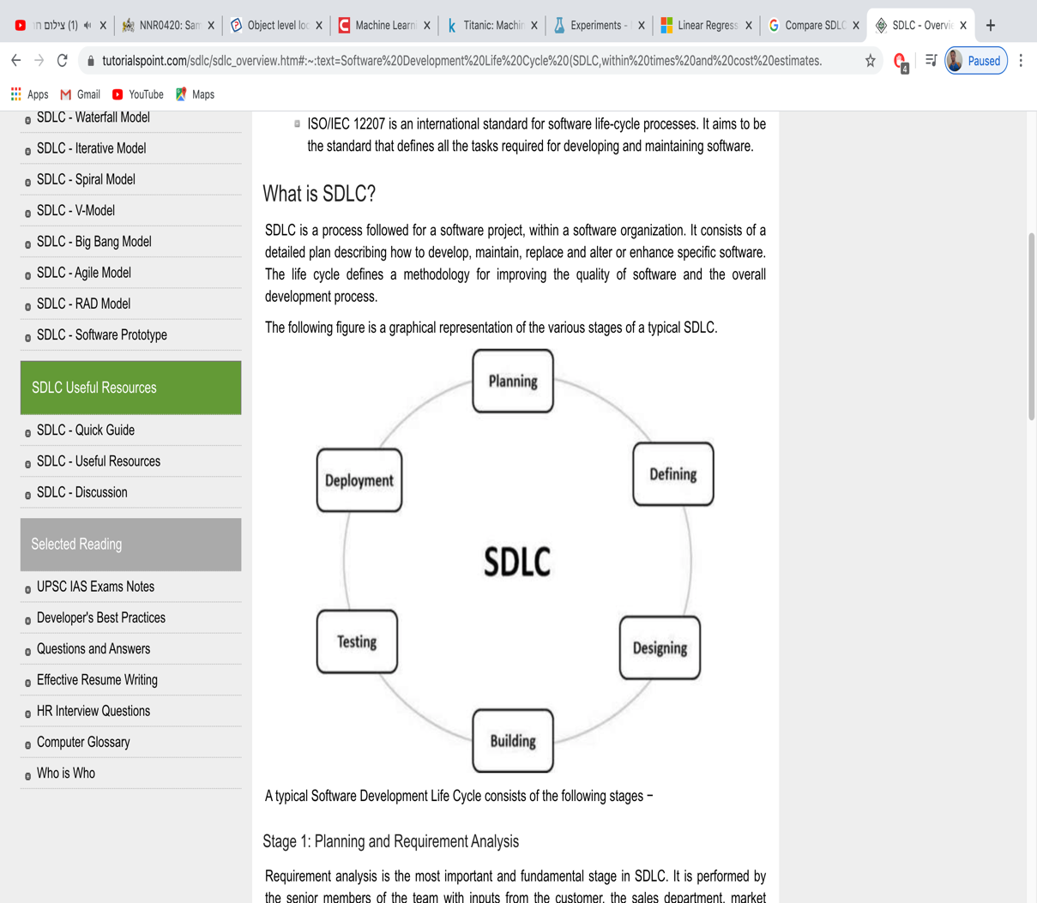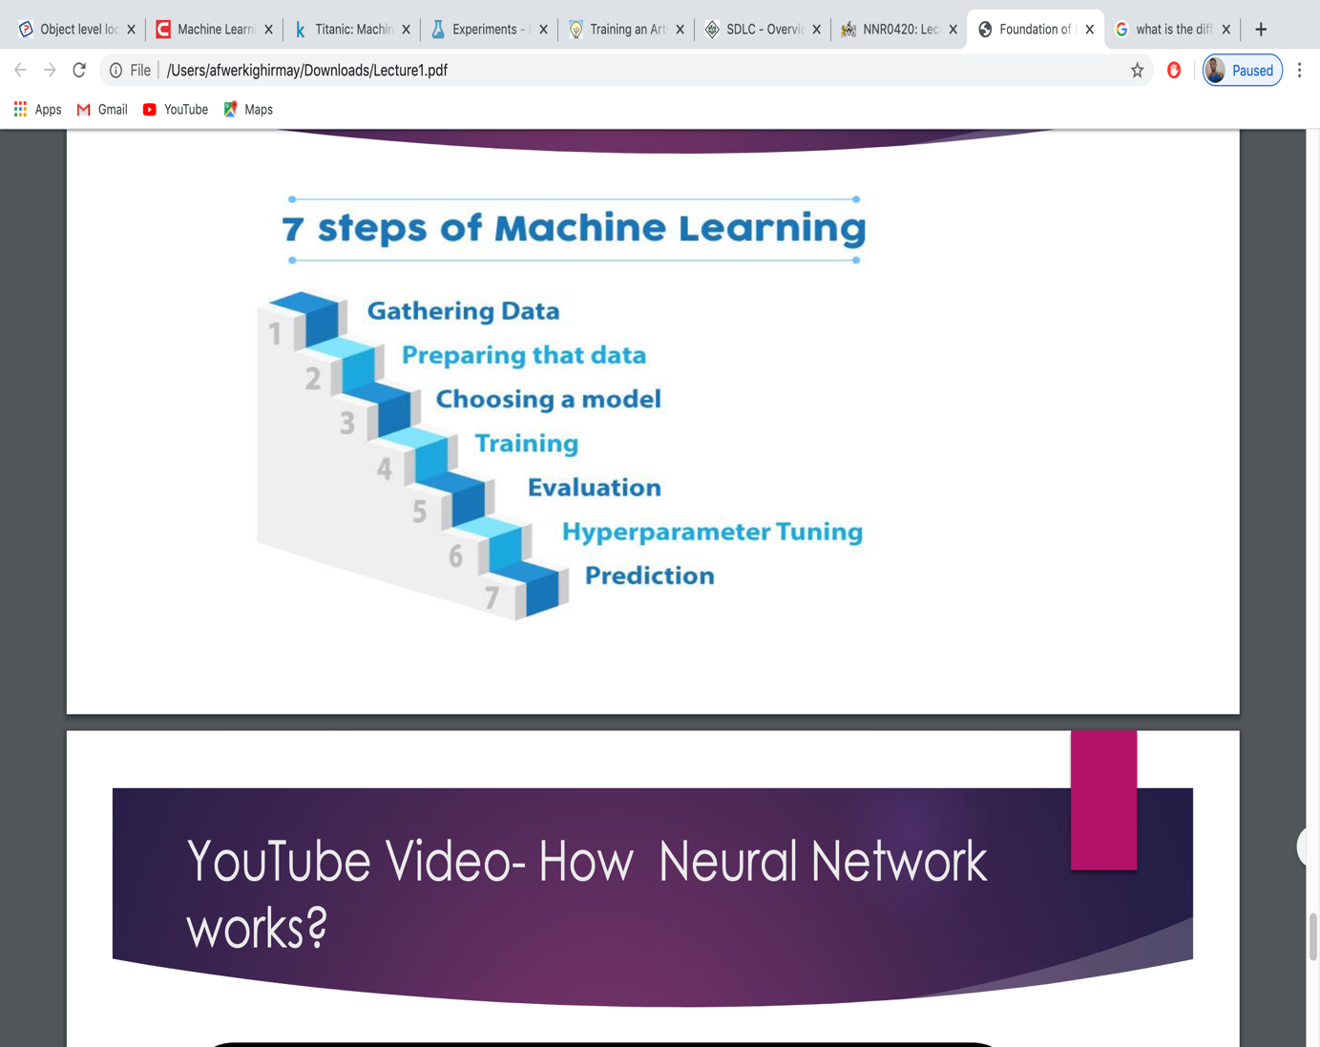

# Task 2: Implement train and test a neural network model

### short scenario

The main point is to predict the survivability of the passengers from the Titanic ship. The ship sank back in April 12, 1912, killed 1502 out of 2224 passengers. From the tragic accident I am going to predict who has a chance of survivability based on the dataset.

## Downloading the dataset

I am going to download the dataset from<https://www.kaggle.com/c/titanic/data>.

After I download the dataset the next step is to open Azure machine learning. From Azure I am clicking “experiment” then there is a button says “new” at the left of the azure machine learning panel. I click “new” to get the dataset into the azure machine learning (Kaggle, 2016).

Uploaded dataset

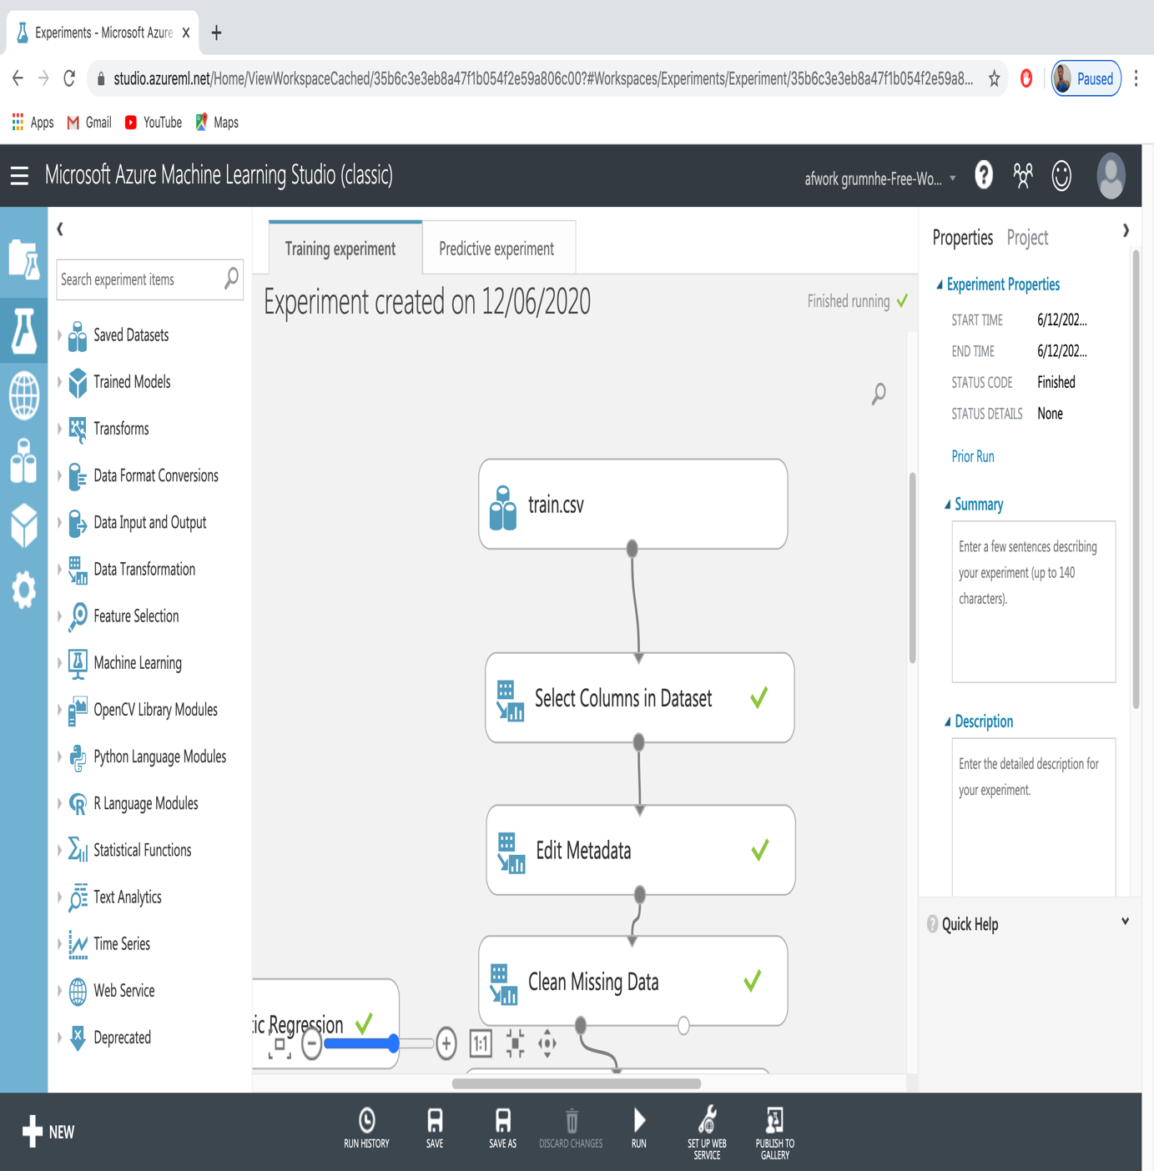

To see that dataset I clicked write on the train.csv dataset

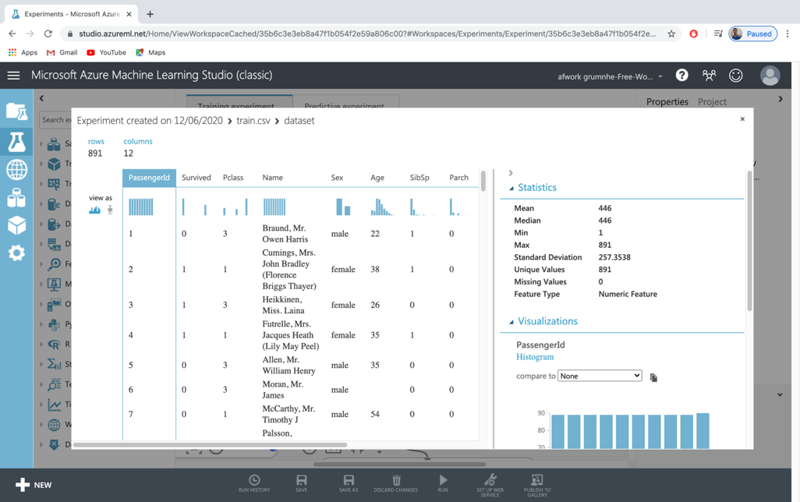

## Prepare the dataset for feeding into the neural network model.

In practical scenarios, most of the time we would find that the data available for predictive analysis is not fit for the purpose. This is primarily because of two reasons:

In the real world, data is always messy. It usually has lots of unwanted items, such as missing values, duplicate records, data in different formats, data scattered all around, and so on.

Quite often, data is either required in a proper format or needs some pre-processing so that it is ready before we apply machine learning algorithms to it for predictive analysis.

So, we need to prepare the data or transform our data to make it fit for the required analysis. ML Studio comes with different options to prepare our data.

## Data preparation

In order to prepare the dataset there are two activities that has to be done. This are **normalizing** the data and **splitting** the data.

### Normalizing data

On the **normalization** the data has to be changed from quantitative to qualitative and it has to be normalized.

For my scenario in order to have a good accuracy on the prediction I have to remove unnecessary columns. Therefore I am going to drag and drop the **select columns in dataset** in to the azure canvas as it shows on the following picture.

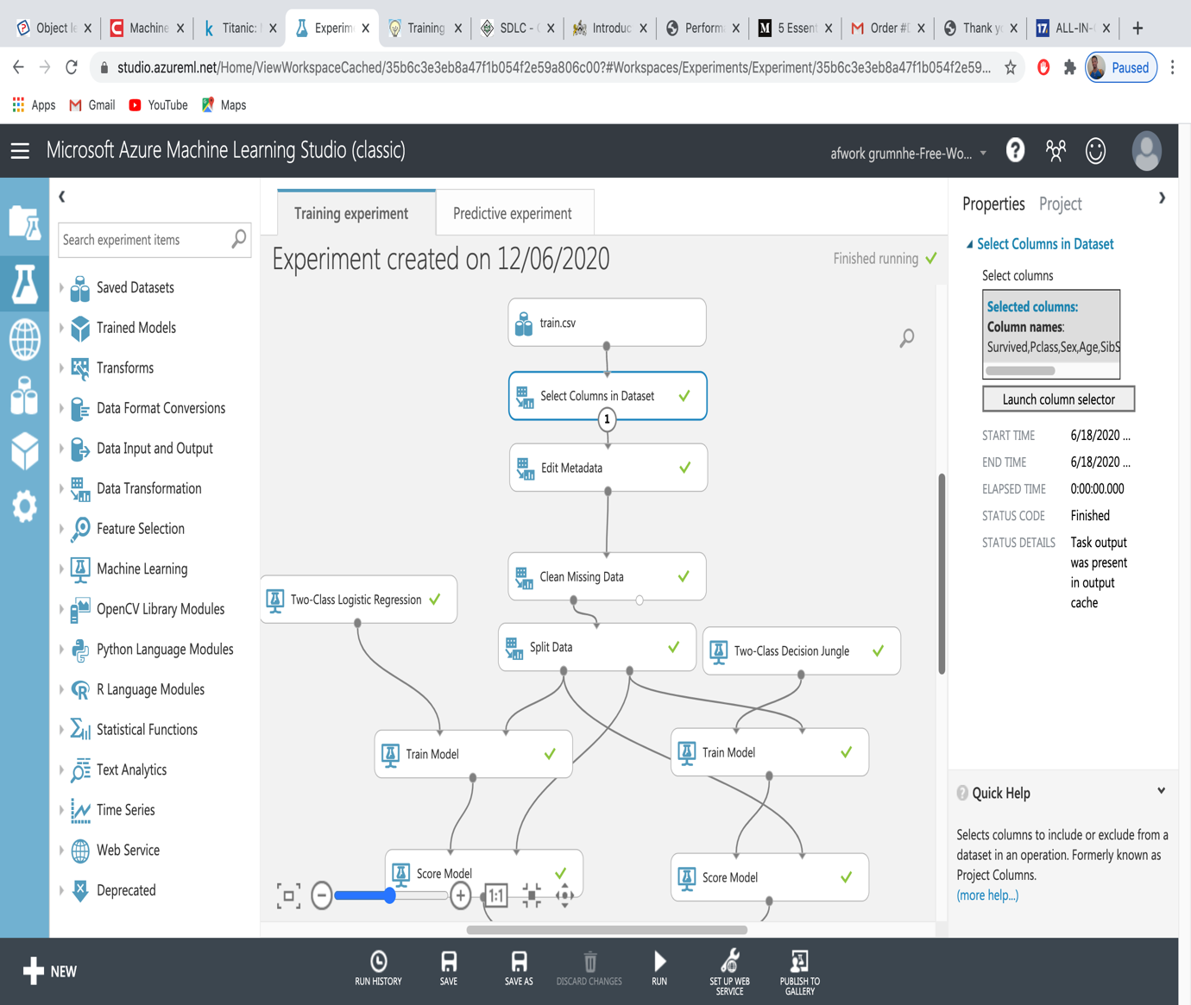

To filter I clicked **Lunch column selector** and selected survived, plass, sex, age, sibSp, parch, fare, and Embarked. Once I select what I need I filtered the rest. as it shows on the picture below

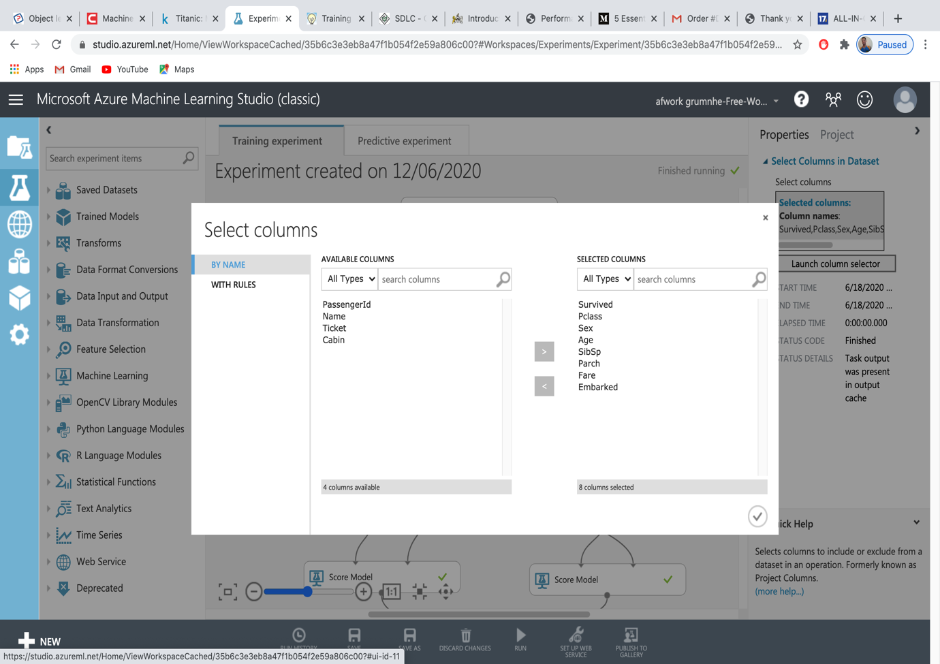

Once the selection is done the next step in the make the data categorical. In order to make the data categorical I am going to drag and drop **Edit Metadata** in to the canvas. Once I do that I am going to click **launch column** and select **Survived**, **Pclass**, **SibSp**, and **Parch** fields. In the **categorical section** I am also going to select **Make categorical** as it shows on the following picture.

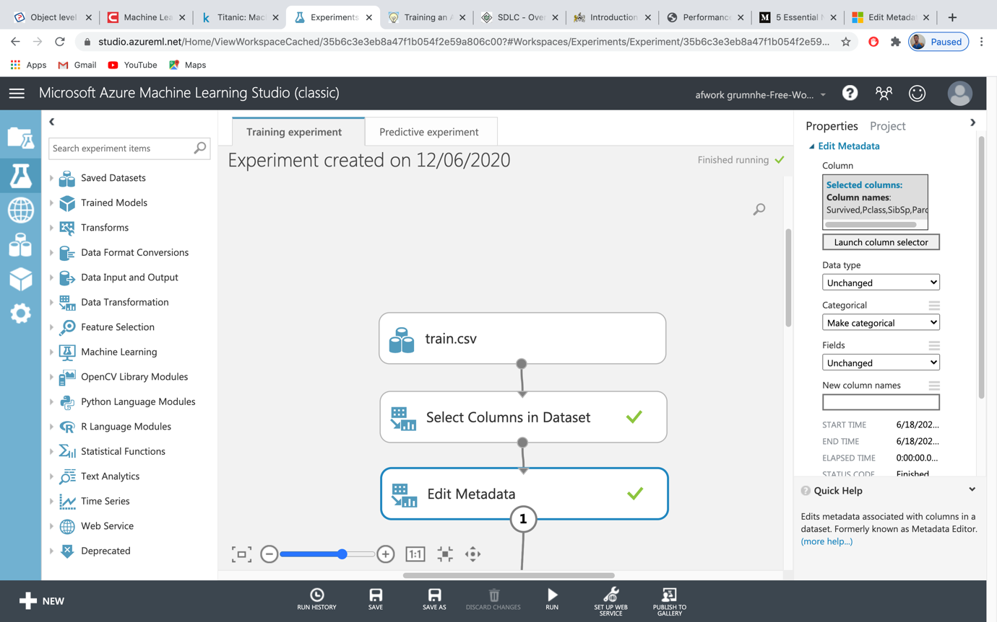

In this step I run the algorithms to see how its going to appear. However when I click **visualize** the data I realize there are some missing data in the **age** column.

### Cleaning to missing data

For the better accuracy of the model I am going to remove the row that has a missing data. In order to do that I am going to drag and drop the **Clean Missing Data** in to the canvas and connect it to the **Edit Metadata**. Then I am going to **Launch column selector** and select the **age**. And I am also going to set the cleaning mode to **Remove entire row** in order to remove all the rows that has a missing data. As it shows on the following picture.

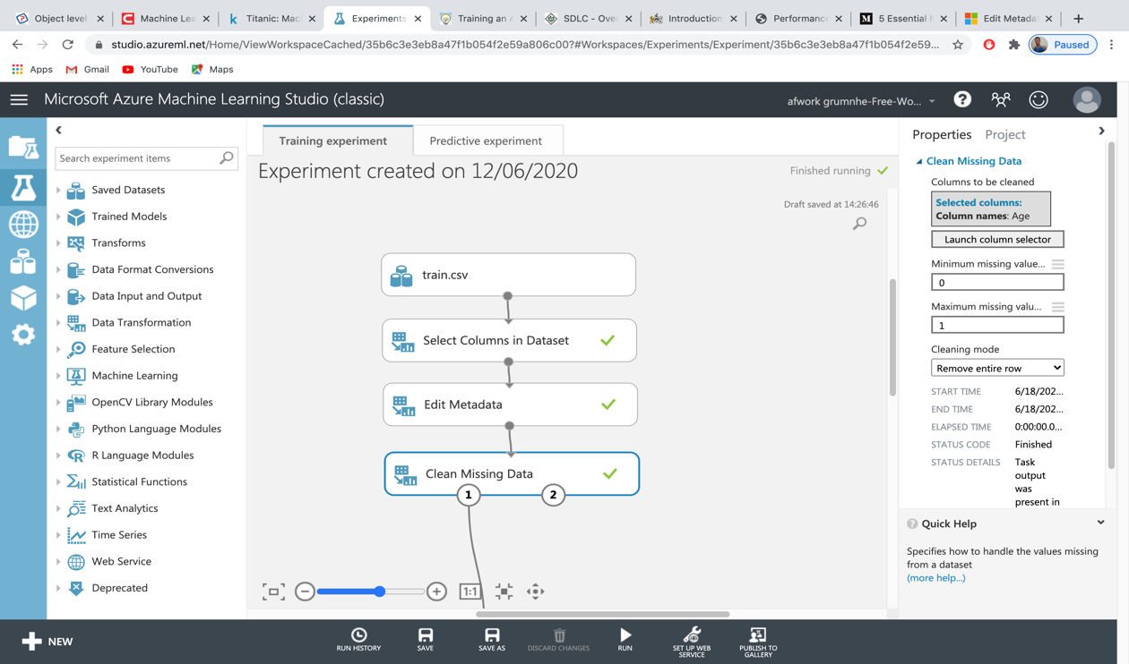

### Splitting the data

After normalizing the data the next step is **splitting** data(portioning). The data have to be divided in to two. Which are the training and the testing.

As the name of the datasets suggest I am going to use the training dataset to train the model and test dataset to check the accuracy of my prediction. In order the split the data I am going to drag and drop the **Split data** in the canvas and connect it to the **Clean Missing Data**. Then I am going to split the data for the training model 0.8 (80%) of the data and test model to 0.2(20%) of the data as it shows on the picture below.

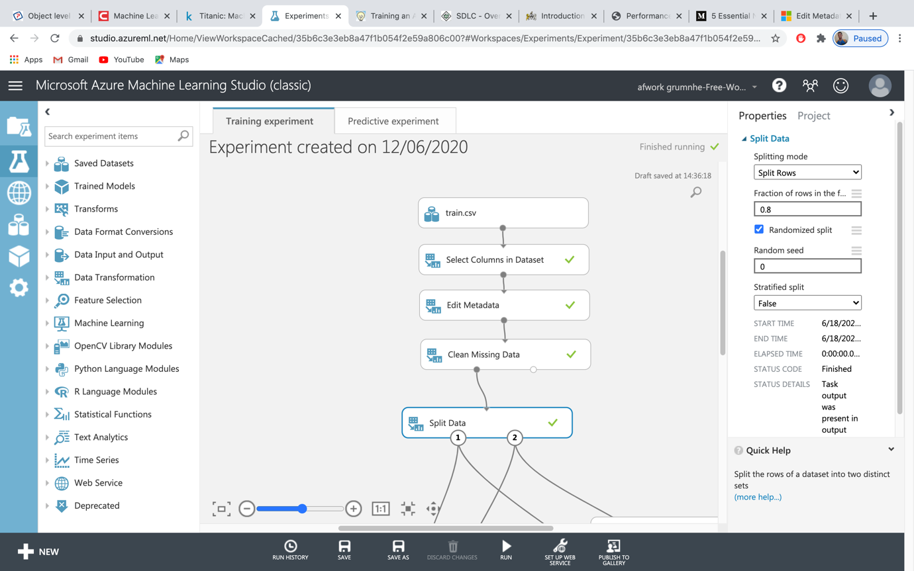

# Task 3: The accuracy of the outcome using neural network model

## Choice of your Neural Network Algorithm

Once the preparation and splitting the data done the next stage is to train the model. In order to train to model I am going to drag and drop the **Two-Class Logistic Regression** model and **Train model** in to canvas. After that I going connect the **Train model** to **split data** and **Two-Class Logistic Regression** to **Train model.**

### What is Two-Class LogisticRegression model and why am I using it?

Logistic regression is one of very well-known supervised learning model for statistical techniques that help to predict the probability of an outcome. This algorithm predict the probability of events by fitting the data to a logistic function.

Therefore the main benefit of **Two-Class Logistic Regression** is, it run through the algorithm multiple times to ensure the best accuracy of the predicted solution is achieved.

In my training model process before I run the model I have to tell for the train model to run the **survived** column only as it shows on the picture below.

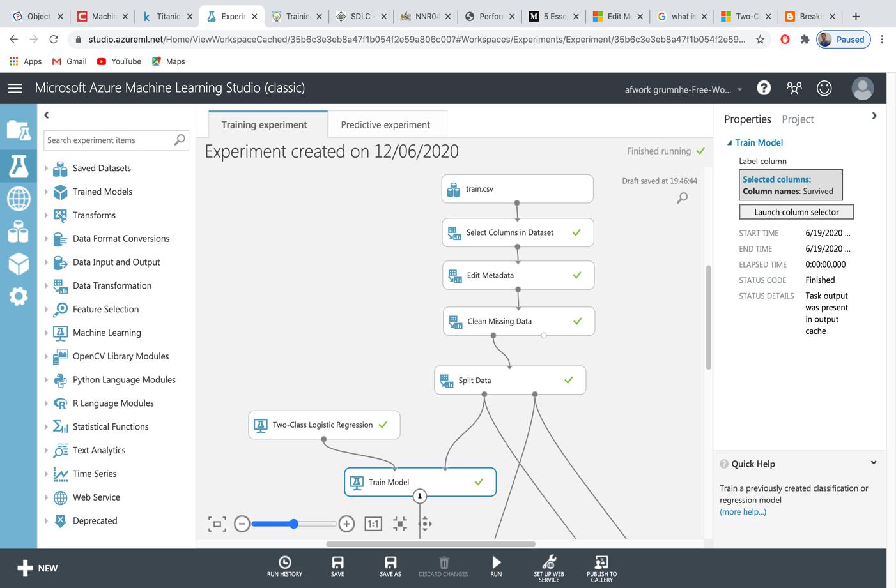

## Train the dataset and discuss about the outcome

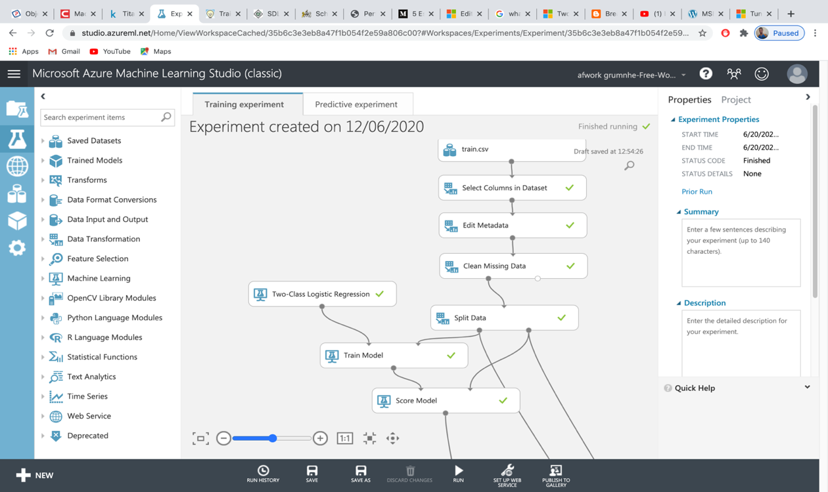

After I split the data in to two part I am going to use the first 80% of the data to train the model. The train model will take **Two-Class Logistic Regression** algorithm and a training dataset to train the model. Moreover as **Two-Class Logistic Regression** algorithm is part of a supervised learning model I have to tell to the model what level to train. Which in this case I am going to train the **survived** column. Once I train this model I am going to use it to predict values for new input which am going to show later. (BI, 2015), (Microsoft, 2018)

The **Two-Class Logistic Regression** model shows the following`;

Feature Weights

|  |  |
| --- | --- |
| Feature | Weight |
| Age | -1.78058 |
| Sex_female_0 | 1.1652 |
| Sex_male_1 | -1.15757 |
| Pclass_3_2 | -1.08641 |
| Pclass_1_0 | 0.863341 |
| Embarked_C_0 | 0.46206 |
| SibSp_1_1 | 0.417038 |
| Bias | 0.365092 |
| SibSp_0_0 | 0.324459 |
| Parch_1_1 | 0.147635 |
| SibSp_4_4 | -0.103261 |
| SibSp_3_3 | -0.0520224 |
| Embarked_Q_1 | -0.0511955 |
| Pclass_2_1 | 0 |

### The next step is to score

The Score Model takes in a trained model (which is the output of the **Train Model** module) and a testing dataset. Therefore I am going to connect the **score model** to the **split data** to get the test data and **train model** to get the trained model as it shows on the following picture.

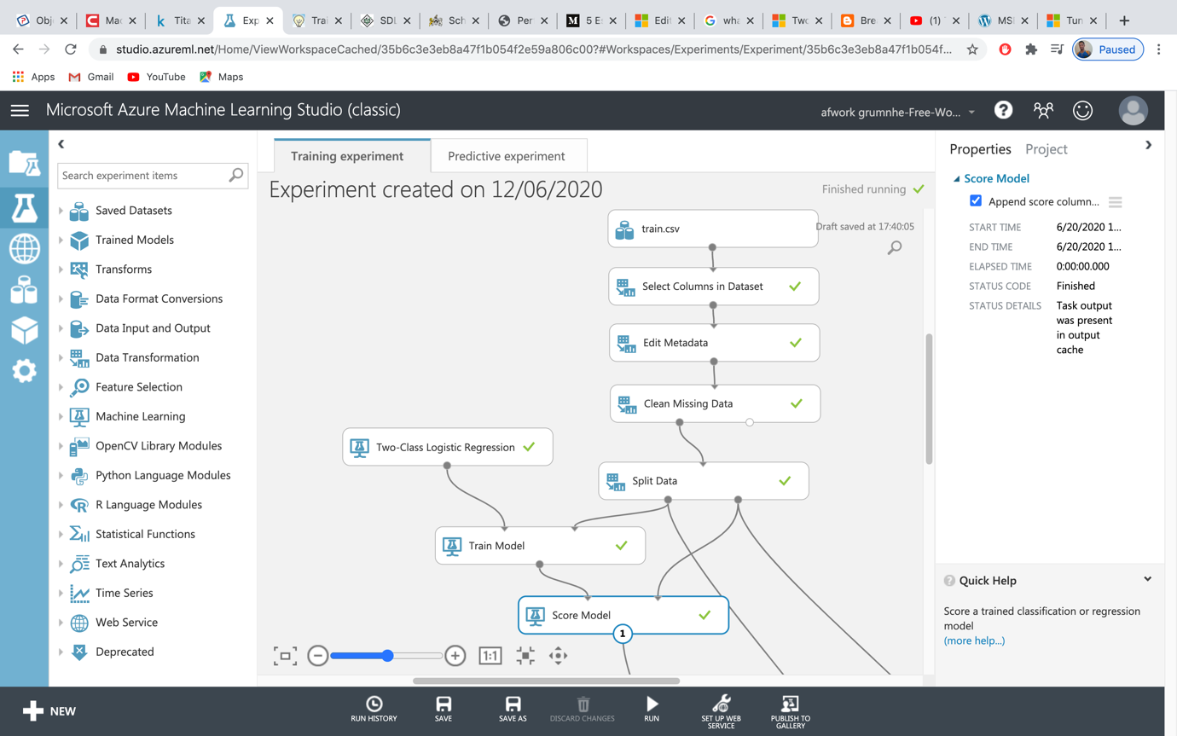

After running the experiment I am going to select **scored Labels** column which apply the test dataset against the learning model. The column close to it, Scored Probabilities, shows the certainty of the prediction. With the Scored Labels column chosen, take a look at the right-side of the screen or above the chart, I am going select Survived for the item named compare with. This plots a graph known as the confusion matrix ((classic), 2018).

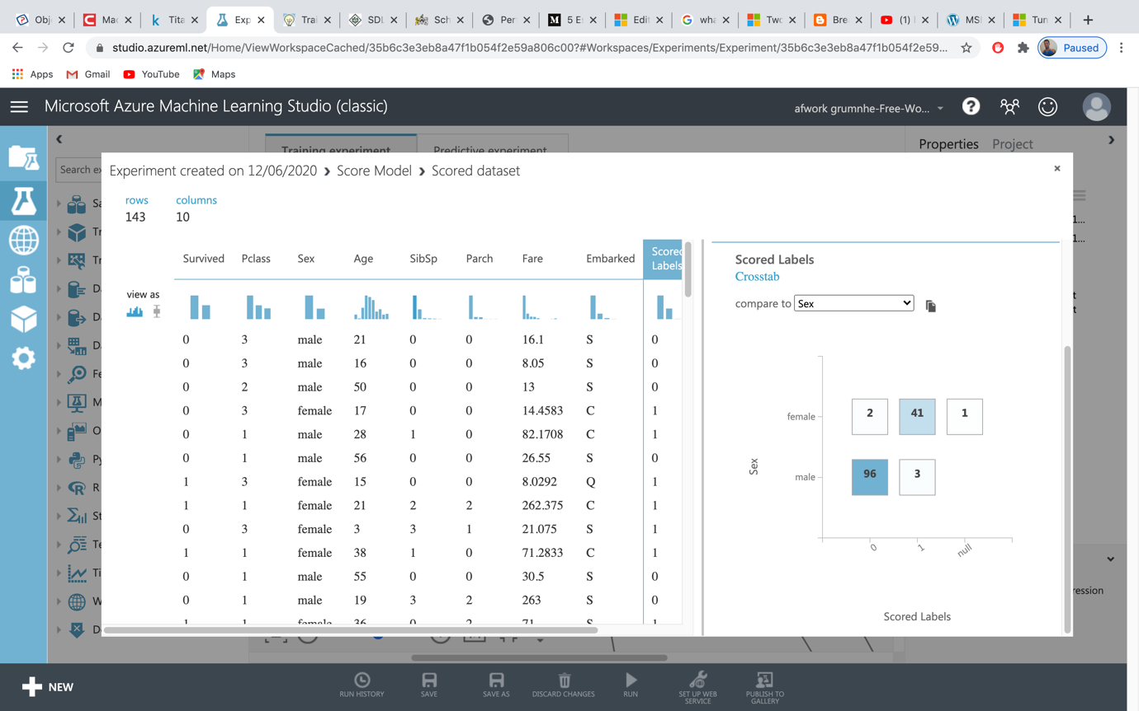

To understand the score 1 means survived and 0 means died.

As the graph shows:

96% of male and 2% of female are died.

3% of male and 41% of females are survived.

## Validation

In order to validate and get the accurate answer I have to compare the accuracy of **Two-Class Logistic Regression** algorithm with another algorithm. For this matter I am going to use **Two-Class Decision Jungle** algorithm. The main importance of **Two-Class Decision Jungle** algorithm is more than one decision trees are assembled to obtain better predictive performance.

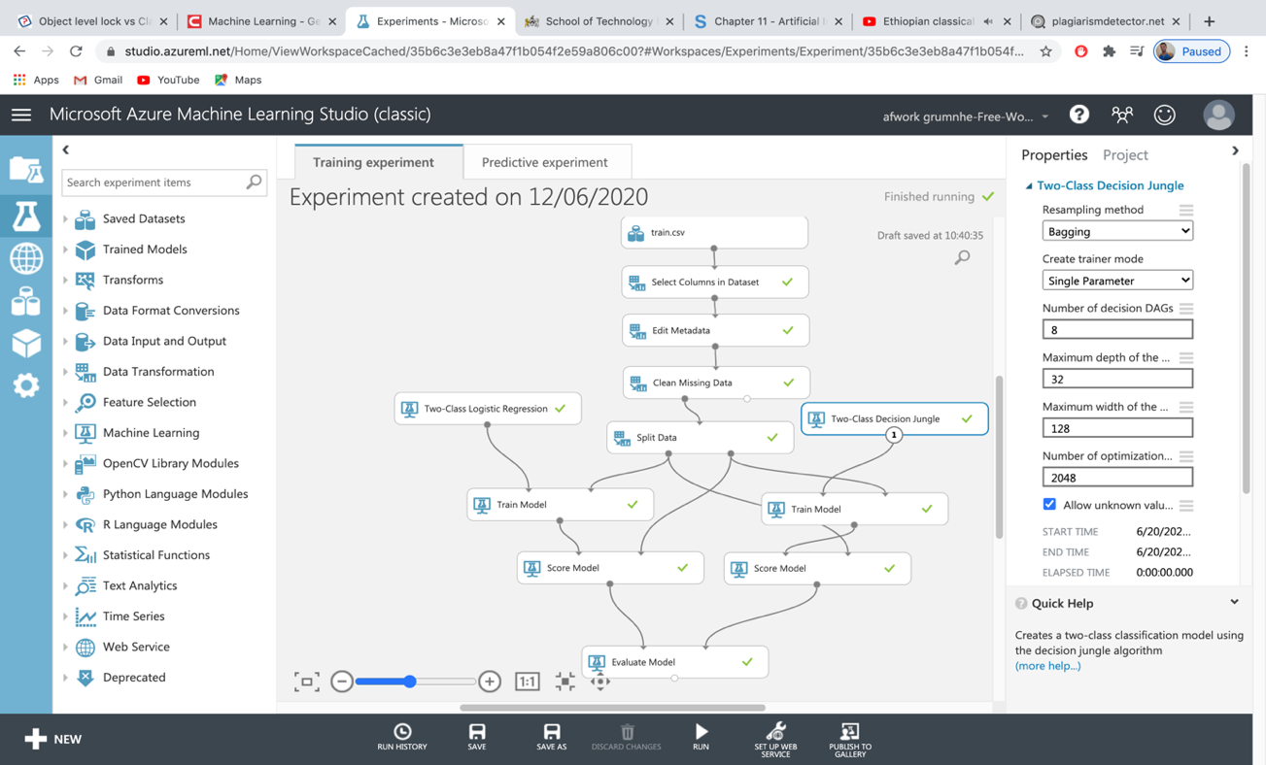

In the following picture the blue shows the **Two-Class Logistic Regression** algorithm and the red shows the outcome of the **Two-Class Decision Jungle** algorithm**.**

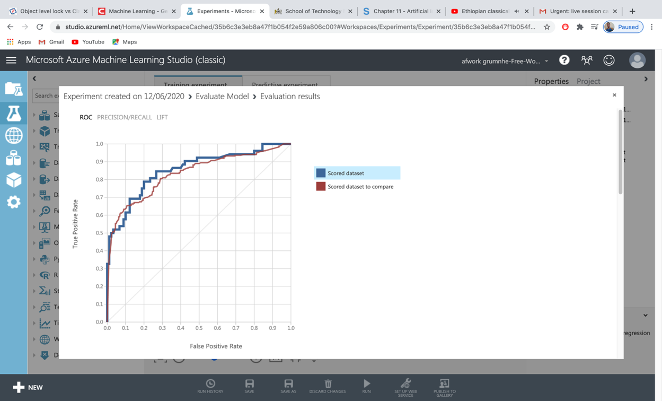

Once I click the blue colour which is the **Two-Class Logistic Regression** it shows the following accuracy outcome.

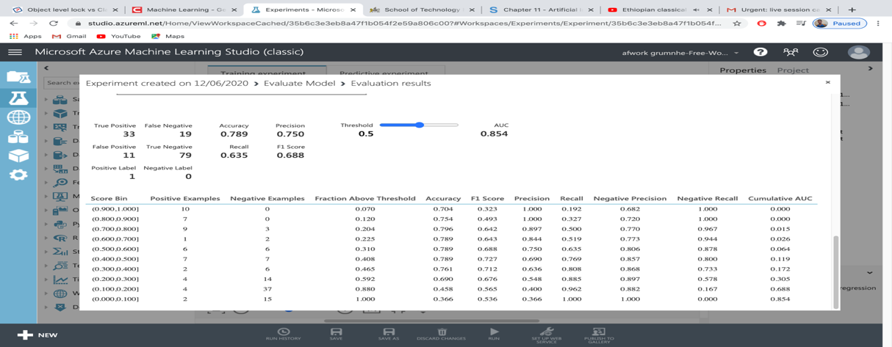

On the other hand when I click the red which shows the outcome of **Two-Class Decision Jungle.** It shows the following outcome which is not very different from the **Two-Class Logistic Regression** outcome that I have shown at the top.

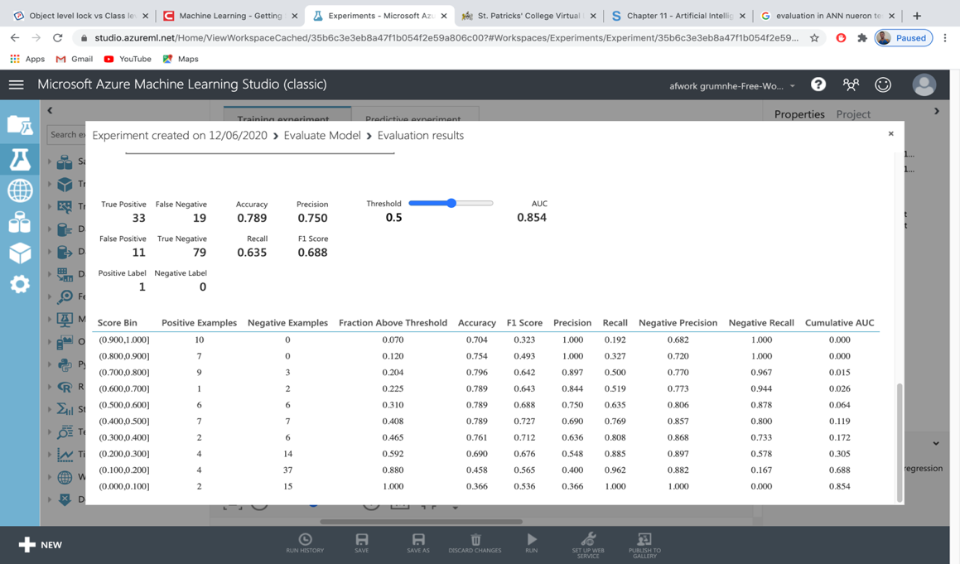

### To clarify a bit more.

**True Positive**: means the correct prediction of the algorithm with true outcome. Which in my case the **True Positive** shows the saviour of the titanic ship.

**True Negative**: means the true prediction of the passenger who were not survived from the disaster.

**False Positive:** means even though the model predicted as positive the reality is negative. Which in the Titanic case the model is predicted as survived but in reality they didn’t survive.

**False Negative:** means the model predicted as negative but the reality is not negative. In this case the model predicted as passengers who are not survived but the reality they survived.

## Tune the model

Her I am going to explain the two algorithms report

|  |  |  |  |  |  |
| --- | --- | --- | --- | --- | --- |
| algorithms | True Positive | False Negative | True negative | False positive | Accuracy |
| Two-Class Decision Jungle | 155 | 82 | 298 | 36 | 0.793(79) |
| Two-Class Logistic Regression | 33 | 19 | 79 | 11 | 0.789(79) |

### Total survivability of the passengers

As you can see on the following picture 79% are on the zero axis which means 79% of passengers from Titanic ship are died. As 0 stands for people who died on the tragic accident. However 33% are on the one(1) axis which means 33% of the passengers are survived.

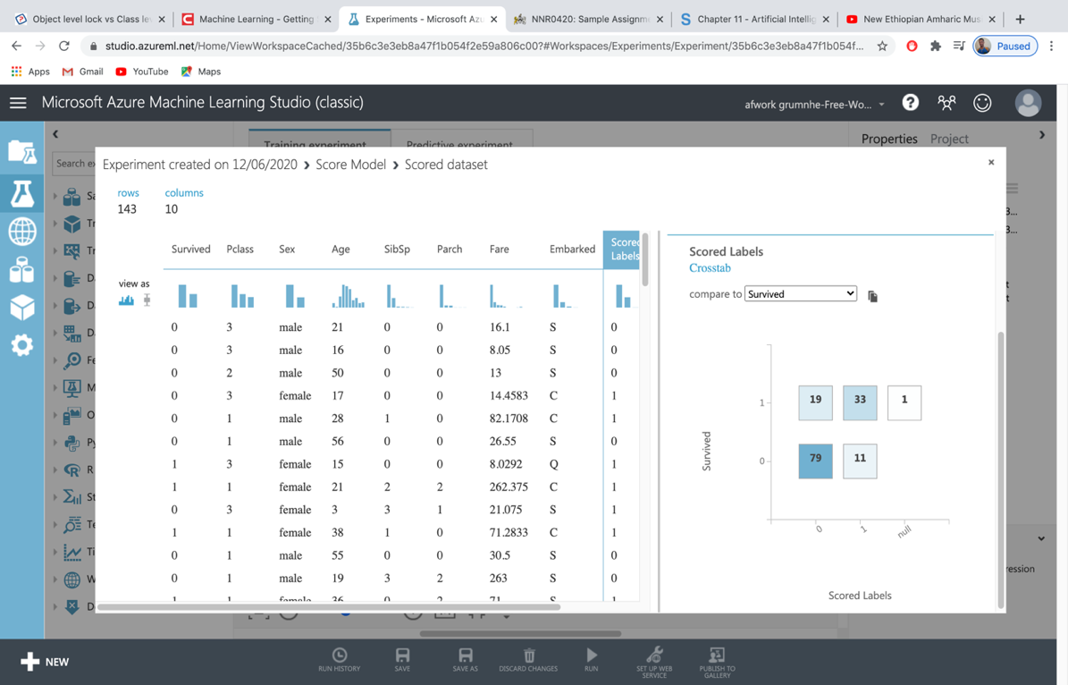

### Survivability based on gender

96% of male and 2%of female predicted as died. On the other hand 42% of female passengers and 3% of male passengers predicted as survived.

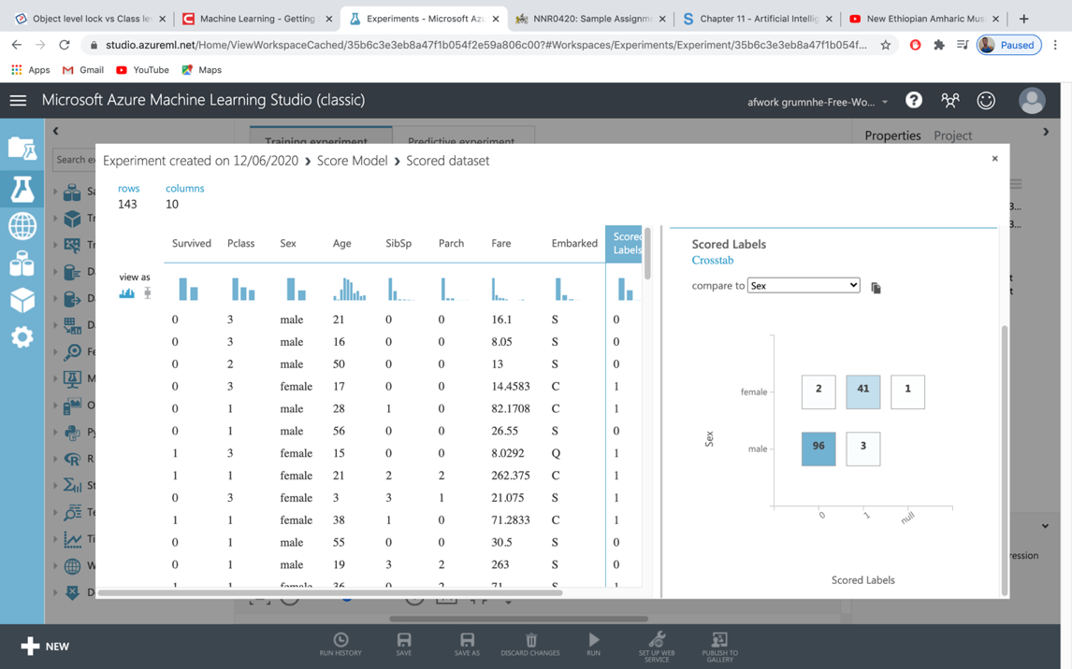

### Survivability based of classes

The death of the passengers are different based of their class. For example the first class passengers died 21%, second class 22%, and 3rd class passenger died55%.

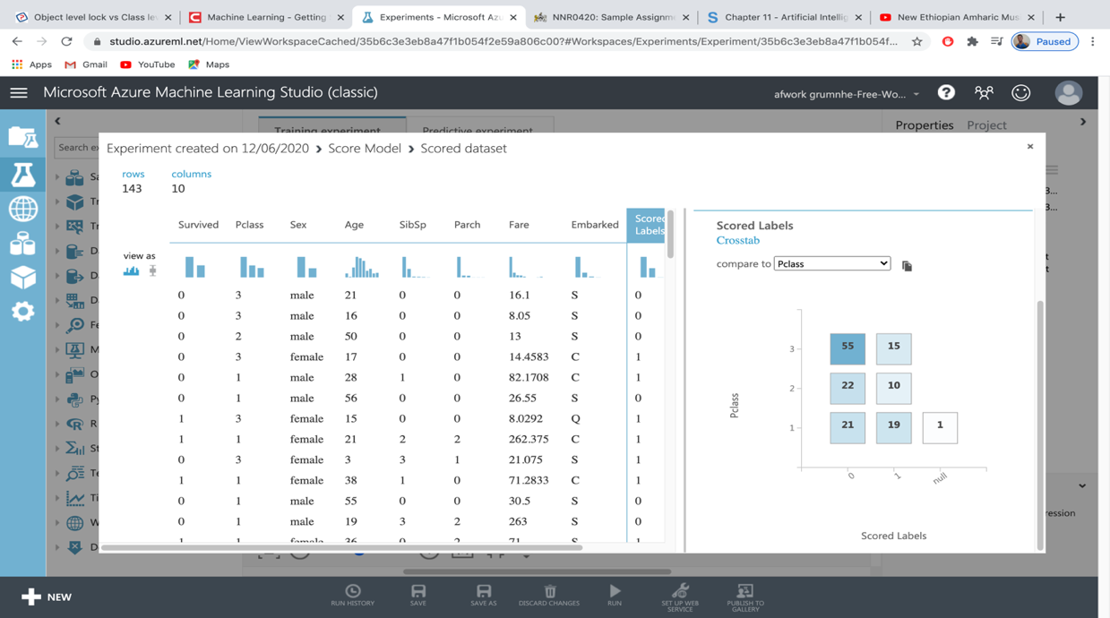

## Finally the web API

Finally the following web API is available for any kind of test if its needed to know the accuracy of my trained model.

EJ4DJrmOO3CUDO8yoRcVPnYJA4yLPjNbGNsduKz1JrvTLjdhp9i38tocRzMCheV+fGpbk3V1CJKTUh0fwxEIJA==

# Conclusion

Overall on task one of this assignment I explained about different types of neural networks and the different paradigm of ANN. Furthermore in this task I also explained the human centric AI and software tools and models that can be used for training ANN. Finally on this task I tried to compare the SDLC and ANN models.

On the task two I explained the process of downloading the data from Kaggle, importing to azure machine learning studio and the preparation of the data. Furthermore on this task I also explained how to clean the data and split the data.

On task three I explained about the chosen algorithms to train the model and discussed the training process and the outcome of the model training. furthermore in this task I also explained the tuning model and accuracy of the training model.

# Bibliography

(classic), M. A. M. L. S., 2018. *Microsoft Azure Machine Learning Studio (classic).* [Online]   
Available at: https://studio.azureml.net/Home/ViewWorkspaceCached/35b6c3e3eb8a47f1b054f2e59a806c00?#Workspaces/Experiments/Experiment/35b6c3e3eb8a47f1b054f2e59a806c00.f-id.8da0d91634904fc7882af1eb66ef4d3c/ViewExperiment  
[Accessed 20 6 2020].

avison, d., 2008. *information systems development.* 4th ed. Berkshire: MC Graw Hill Education.

BI, B., 2015. *Azure Machine Learning.* [Online]   
Available at: http://breaking-bi.blogspot.com/2016/12/azure-machine-learning-classification.html  
[Accessed 25 5 2020].

Brookshear, J., 2018. *Computer Science.* 12th Edition ed. Pennsylvania: GLOBAL EDITION.

Kaggle, 2016. *Titanic: Machine Learning from Disaster.* [Online]   
Available at: https://www.kaggle.com/c/titanic/data  
[Accessed 20 6 2020].

Microsoft, 2018. *Two-Class Logistic Regression module.* [Online]   
Available at: https://docs.microsoft.com/en-us/azure/machine-learning/algorithm-module-reference/two-class-logistic-regression#:~:text=In%20this%20article&text=This%20article%20describes%20a%20module,modeling%20many%20kinds%20of%20problems.  
[Accessed 25 6 2020].

Nicholson, C., 2016. *pathmind.* [Online]   
Available at: https://pathmind.com/wiki/comparison-frameworks-dl4j-tensorflow-pytorch  
[Accessed 10 June 2020].